H.T No
Regulations:
A20

Sreenidhi Institute of Science and Technology
(An Autonomous Institution)
Code No: 8HC15 Date: 22-Feb-2023 (FN)

B.Tech II-Year I- Semester External Examination, February/March-2023 (Regular/Supplementary)
COMPLEX ANALYSIS, PROBABILITY, AND STATISTICS (CIVIL and ME)

Time: 3 Hours Max.Marks:70

Note: a) No additional answer sheets will be provided.
b) All sub-parts of a question must be answered at one place only, otherwise it will not be valued.
c) Missing data can be assumed suitably.
Bloom's Cognitive Levels of Learning (BCLL)

Remember | L1 | Apply | L3 | Evaluate | L5
Understand | L2 | Analyze | L4 | Create | L6

Part - A Max.Marks:20

Answer all QUESTIONS.

 |  | BCLL | CO(s) | Marks
1 | Let be an analytic function. Show that is constant. If 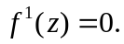 | L1 | CO1 | [2M]
2 | State the Cauchy integral theorem. | L1 | CO2 | [2M]
3 | If X is a poisson variate such that 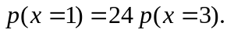 Find the probability 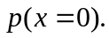 | L1 | CO3 | [2M]
4 | A normal population has a standard deviation of 1. A sample of size 400 is collected for testing. Find the standard error of the mean of sampling distribution. | L2 | CO4 | [2M]
5 | Write the objectives of quality control. | L1 | CO5 | [2M]
6 | Define Type-I and Type –II errors. | L1 | CO6 | [2M]
7 | Define isolated singularity and removable singularity of a complex function. | L1 | CO2 | [2M]
8 | If the size of the sample is 20. The size of population is 100. Find the correction factor of the population. | L1 | CO4 | [2M]
9 | Write few applications of 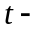distribution. | L2 | CO6 | [2M]
10 | If X is a binomially distributed random variable with 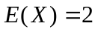 and 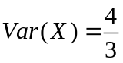. Find the distribution of X. | L1 | CO3 | [2M]

Part – B Max.Marks:50
ANSWER ANY FIVE QUESTIONS. EACH QUESTION CARRIES 10 MARKS.

 |  |  | BCLL | CO(s) | Marks
11. | a) | Show that the function 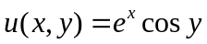 is harmonic. Determine its harmonic conjugate 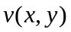and find the analytic function 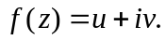 | L1 | CO1 | [5M]
 | b) | Show that 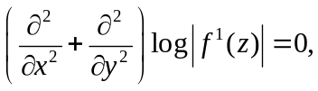 where is an analytic function. | L1 | CO1 | [5M]
12. | a) | Show that, by Residue theorem, 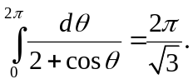 | L2 | CO2 | [5M]
 | b) | Expand 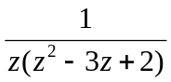 in the region 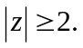 | L1 | CO2 | [5M]
13. | a) | For the continuous probability function 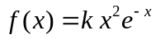, when 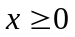 find  i) k ii) mean iii) variance. | L2 | CO3 | [5M]
 | b) | In a distribution exactly normal, 7% of the items under 35 and 89% are under 63. What are the mean and standard deviation of the distribution? | L2 | CO3 | [5M]
14. | a) | A random sample of size 81 was taken whose variance is 20.25 and mean 32. Construct 98% confidence interval. | L2 | CO4 | [5M]
 | b) | A population consists of 5, 10, 14, 18, 13, 24. Consider all possible samples of size two which can be drawn without replacement from the population. Find i) The mean of population. ii) The standard deviation of the population. iii) The mean of the sampling distribution of means. iv) The standard deviation of sampling distribution of means. | L2 | CO4 | [5M]
15. | a) | What are the various charts which are used for process control in SQC? Discuss the relative advantages and disadvantages of use of control charts. | L1 | CO5 | [5M]
 | b) | A weighting machine gives the packets of a given weight. Ten sample of size 5 each were checked and the weights were found to be as follows:  Calculate the values for the central lines (mean) and control limits for the mean chart and the range chart. For 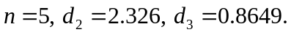 | L3 | CO5 | [5M]
  Sample no. | 1 | 2 | 3 | 4 | 5 | 6 | 7 | 8 | 9 | 10
  Mean | 49 | 42 | 38 | 45 | 47 | 45 | 37 | 51 | 46 | 44
  Range | 6 | 5 | 7 | 4 | 8 | 6 | 5 | 4 | 7 | 6
16. | a) | Random samples of 400 men and 600 women were asked whether they would like to have a flyover near their residence. 200 men and 325 women were in favor of the proposal. Test the hypothesis that proportions of men and women in favor of the proposal are same at 5% level. | L3 | CO6 | [5M]
 | b) | From the following data find whether is any significant liking in the habit of taking soft drinks among the categories of employees. | L3 | CO6 | [5M]
  Soft drinks | Employee |  |  | Total
  Soft drinks | Clerks | Teachers | Officers | Total
  Pepsi | 10 | 25 | 65 | 100
  Thumps up | 15 | 30 | 65 | 110
  String | 50 | 60 | 30 | 140
  Total | 75 | 115 | 160 | 350
17. | a) | Show that the real and imaginary parts of the function 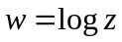 satisfy the Cauchy-Riemann equations, when is not zero. | L1 | CO1 | [4M]
 | b) | Evaluate by Cauchy’s integral formula 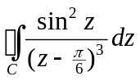 where 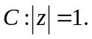 | L1 | CO2 | [3M]
 | c) | Define conditional probaility. | L2 | CO3 | [3M]
18. | a) | The mean of certain normal population is equal to the standard error of the mean of the samples of 64 from that distribution. Find the probability that the mean of the sample size 36 will be negative. | L1 | CO4 | [4M]
 | b) | Give a brief of the historical development of quality. | L1 | CO5 | [3M]
 | c) | Among 900 people in a state 90 are found to be chapatti eaters. Construct 99% confidence interval for the true population. | L2 | CO6 | [3M]

-- 00 -- 00 –

